**STUMPP SCHUELE & SOMAPPA SPRINGS PVT LTD**

**AURANGABAD PLAT**

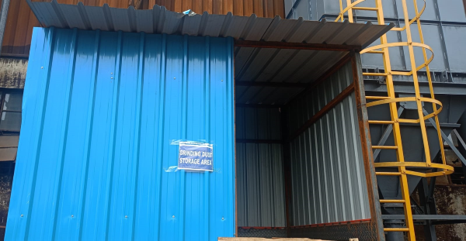NEWLY CONSTRUCTED GRINDING DUST STORAGE ROOM

**NEWLY CONSTRUCTED HAZARDUST WASTE STORAGE AREA**

