NAME OF ASSESEE : MR. NITIN RAMDAS ALHAT

ADDRESS OF ASSESEE: M/S SHREE ENTERPRISES

AT NIGHOJE, POST KURULI

TAL-KHED, DIST- PUNE 410501

FINANCIAL YEAR : 2021-22

ASSESSMENT YEAR : 2022-23

SUBJECT : FINANACIAL STATEMENT

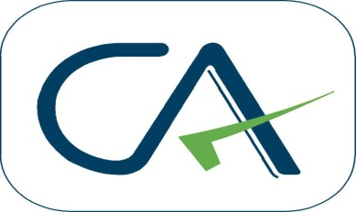

M.A.MUNSHI & CO

CHARTERED ACCOUNTANTS

**Office Add: C/O Umesh Ganesh Jog, Audumbar Banglow, Near Sanjeevani Hospital,**

**Ranubai Mala, Chakan, Tal-Khed, Dist-Pune, 410501**

**Contact No: 9423238539**

**Email Id : mohinijm@gmail.com**