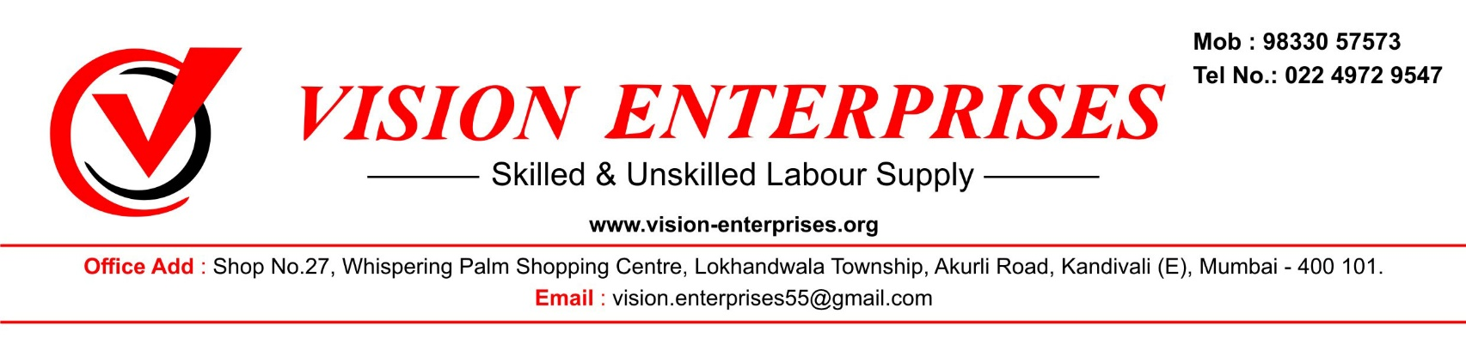

**Date – 27/07/2023**

**Undertaking Letter**

Dear Sir,

This is to inform you that, Our workers working hours complied with the current applicable law.



For Vision Enterprises,

Authority Signatory

HRD, Mumbai