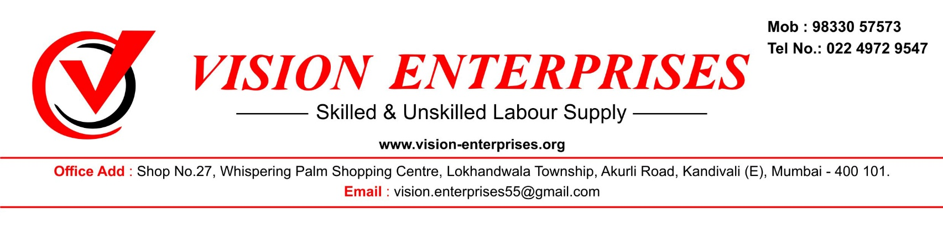

**Date – 27/07/2023**

**Undertaking Letter**

Dear Sir,

This is to inform you that, we did not register any complaint against the contractor in past under Labor Laws.



For Vision Enterprises,

Authority Signatory

HRD, Mumbai