**Date : Feb 26, 2024**

**DECLARATION**

**We Svision Tec Hereby declare that the statement made by in all respects, correct and true to the best of our knowledge and belief; we agree that this declaration shall be the basis of our agreement between us.**

We have no reportable accident record in the past years.

All above declaration have been made with our understanding and if any discrepancies found against our declaration, we are solely responsible for non-compliances.

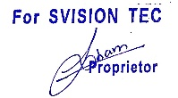

**Svision Tec**