Experience Certificate

We declare that our team is having 15+ years of experience in manufacturing of Shot blasting machines, dust collector, blast rooms & paint booths, powder coating booths and related spares, etc

For FINISHREE EQUIPMENTS PVT. LTD.
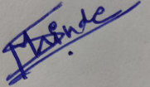
Authorized Signatory

