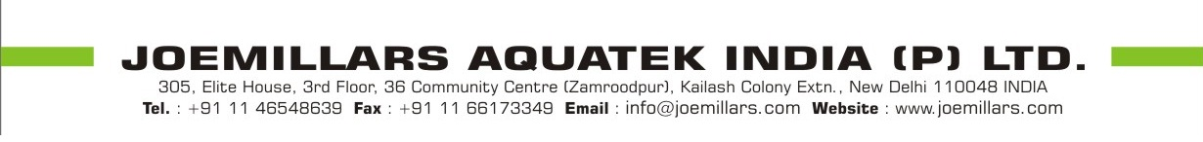

Date : 26.02.2024

DECLARATION

We declare that we have more than 14 years experience in manufacturing and installation of Zincalume Steel Bolted Tanks. We have been running our company since 2003.

