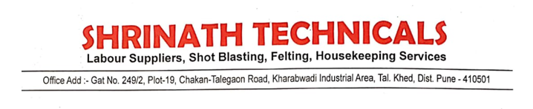

HSE POLICY

We M/S Shrinath Technicals decleared that our organization will be taken care of all of our worker. We will ensired and assured that we will provide all the PPEs and awareness to avoid any accidents