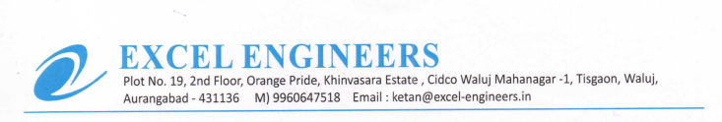

**TO WHOM IT MAY BE CONCERN**

We M/S Excel Engineers - channel partner of UFS Protect (India) declared that we are complied with the current applicable law in the country relevant workers working hours.