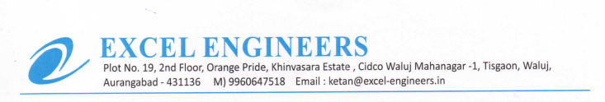

**TO WHOM IT MAY BE CONCERN**

We M/S Excel Engineers - channel partner of UFS Protect (India) declared that we are paid wages paid on the basis of Minimum Wages Act.