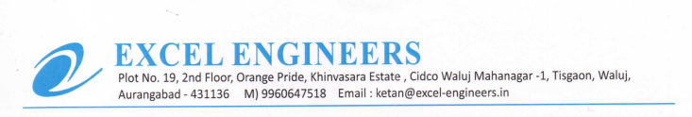

**TO WHOM IT MAY BE CONCERN**

We M/S Excel Engineers - channel partner of UFS Protect (India) declared that we are not associated any Fatalities (Verify from Govt. data / reference check)