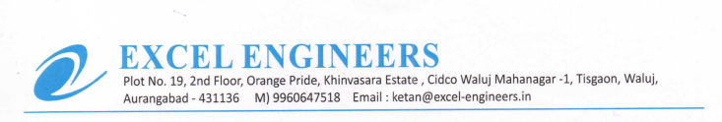

**TO WHOM IT MAY BE CONCERN**

We M/S Excel Engineers - channel partner of UFS Protect (India) declared that we are not associated with any Fire Incident in last 2 years