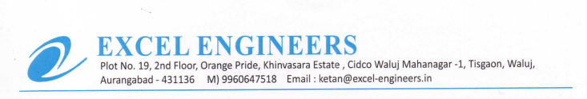

**TO WHOM IT MAY BE CONCERN**

We M/S Excel Engineers - channel partner of UFS Protect (India) declared that we or our organisation not have been prosecuted for an HSE breach or injury to words our employee