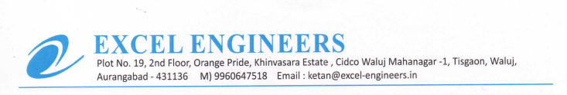

**TO WHOM IT MAY BE CONCERN**

We M/S Excel Engineers - channel partner of UFS Protect (India) declared that our employees are aware of Work Permit System / Work Permit Adherence