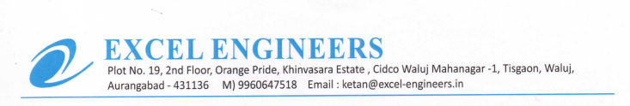

**TO WHOM IT MAY BE CONCERN**

We M/S Excel Engineers - channel partner of UFS Protect (India) declared that our organization have provided tools and equipment which have the holding handle of equipment in good condition