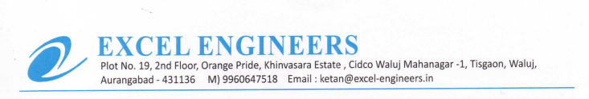

**TO WHOM IT MAY BE CONCERN**

We M/S Excel Engineers - channel partner of UFS Protect (India) declared that our organization have provided tools and equipment which comply with the safety requirements (including not damaged cables, no loose connections, equipped with 3 pin top)