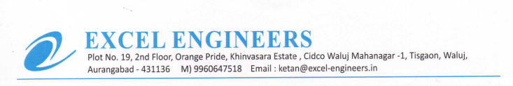

**TO WHOM IT MAY BE CONCERN**

We M/S Excel Engineers declared that we are channel partner of UFS Protect (India) and having more than 4 years of experience in the filed of roof top installation work with various organization and having evidently documents for the same.