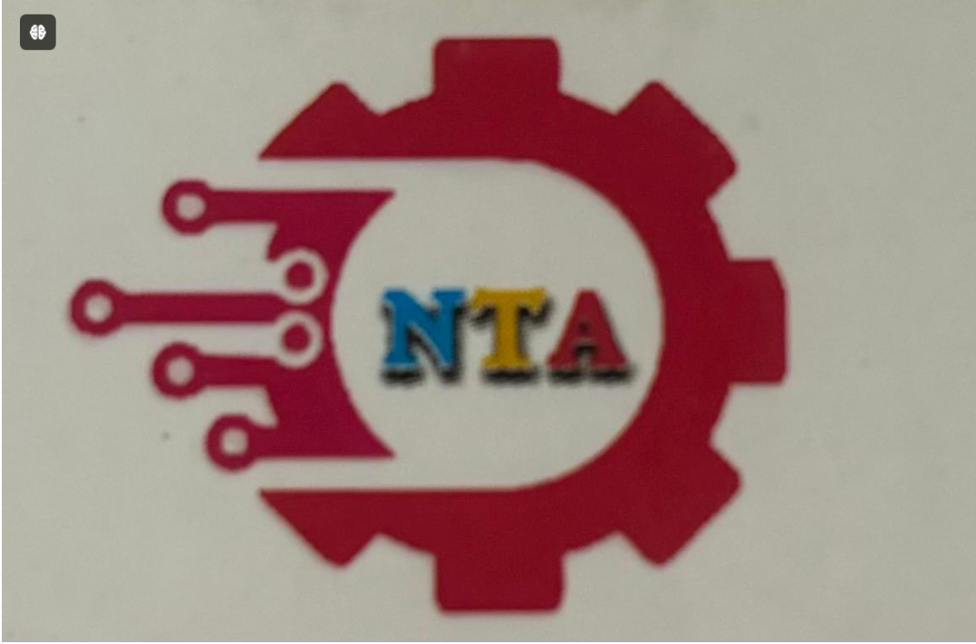**NEW TECH Automation  
 Add : F-43, VISHWESHWAR INDUSTRAIL PREMISES SECTOR-7, PCNTDA, BHOSARI PUNE-411026 India.**

**Mob. :- 8830600465 \ 8090443040  
Email :-** [**newtechautomation2017@gmail.com**](mailto:newtechautomation2017@gmail.com) **Web :-www.newtechautomations.in**

**TRAINING ATTENDANCE SHEET**

**SUBJECT OF TRAINING:- FACULTY:-_______________**

**Date of Training:-___________________________TIMING :-___________DURATION:-___________**

|  |  |  |  |  |  |  |  |  |
| --- | --- | --- | --- | --- | --- | --- | --- | --- |
| **SR NO** | **EMPLOYEE CODE** | **NAME OF THE EMPOLYEE** | **PLANT** | **DESIGANTION** | **DEPARTMENT** | **START OF SESSION** | **END OF SESSION** | **SIGNATURE** |
| **1** | **101** | **RUSHIKEHS HIWALE** | **BHOSARI** | **MAINTANCE ENGINEER** | **FANUC LAB** | **10. AM** | **11.AM** |  |
| **2** | **102** | **KIRAN SANKH** | **BHOSARI** | **MAINAANCE MANAGER** | **SIEMENS LAB** | **10.AM** | **11.AM** |  |
| **3** | **103** | **Gajanan Chaudhari** | **BHOSARI** | **MAINTANCE ENGINEER** | **FANUC LAB** | **10.AM** | **11.AM** |  |
|  |  |  |  |  |  |  |  |  |
|  |  |  |  |  |  |  |  |  |
|  |  |  |  |  |  |  |  |  |
|  |  |  |  |  |  |  |  |  |
|  |  |  |  |  |  |  |  |  |