SITE SAFETY

**NO JOB WITHOUT PERSONEL PROTECTIVE EQUIPMENT**

**ALL VISITORS AND DELIVERY DRIVERS MUST REPORT TO SITE OFFICE**



DANGER –MOULDING AND MELTING AREA

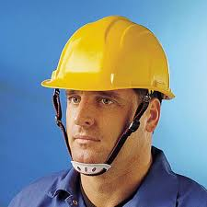

**HEAD PROTECTION MUST BE WORN**

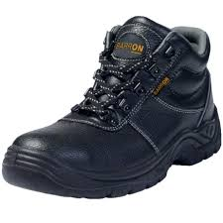

**EYE PROTECTION MUST BE WORN**

**FOOT PROTECTION MUST BE WORN**

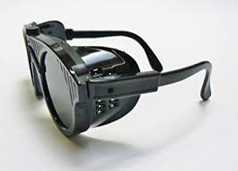

**HI-VIS CLOTHING MUST BE WORN**

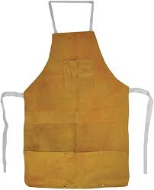

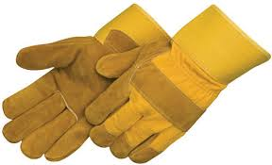

**NO UNAUTHORISED PERSONS BEYOND THIS POINT**

**HI-VIS GLOVES MUST BE WORN**

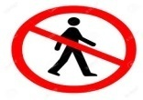

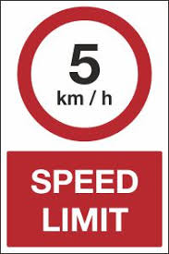

**SPEED LIMIT IN THIS AREA**

**EMERGENCY 24 HOURS TELIPHONE CONTACT NO----SAFETY OFFICER -9756601744 AMBULANCE –108 FIRE STATION-09454418448 POLICE STATION-112**

**BEAMW**

SITE SAFETY

**NO JOB WITHOUT PERSONEL PROTECTIVE EQUIPMENT**

**ALL VISITORS AND DELIVERY DRIVERS MUST REPORT TO SITE OFFICE**



DANGER –MOULDING AND MELTING AREA



**HEAD PROTECTION MUST BE WORN**



**EYE PROTECTION MUST BE WORN**

**FOOT PROTECTION MUST BE WORN**



**HI-VIS CLOTHING MUST BE WORN**





**NO UNAUTHORISED PERSONS BEYOND THIS POINT**

**HI-VIS GLOVES MUST BE WORN**





**SPEED LIMIT IN THIS AREA**

**EMERGENCY 24 HOURS TELIPHONE CONTACT NO----SAFETY OFFICER -9756601744 AMBULANCE –108 FIRE STATION-09454418448 POLICE STATION-112**

**NO JOB WITHOUT PERSONEL PROTECTIVE EQUIPMENT**

SITE SAFETY

**ALL VISITORS AND DELIVERY DRIVERS MUST REPORT TO SITE OFFICE**



DANGER –MOULDING AND MELTING AREA



**HEAD PROTECTION MUST BE WORN**



**EYE PROTECTION MUST BE WORN**

**FOOT PROTECTION MUST BE WORN**



**HI-VIS CLOTHING MUST BE WORN**





**NO UNAUTHORISED PERSONS BEYOND THIS POINT**

**HI-VIS GLOVES MUST BE WORN**





**SPEED LIMIT IN THIS AREA**

**EMERGENCY 24 HOURS TELIPHONE CONTACT NO----SAFETY OFFICER -9756601744 AMBULANCE –108 FIRE STATION-09454418448 POLICE STATION-112**

**BEAMW**

SITE SAFETY

**NO JOB WITHOUT PERSONEL PROTECTIVE EQUIPMENT**

**ALL VISITORS AND DELIVERY DRIVERS MUST REPORT TO SITE OFFICE**



DANGER –FETTLING AND GRINDING AREA



**HEAD PROTECTION MUST BE WORN**



**EYE PROTECTION MUST BE WORN**

**FOOT PROTECTION MUST BE WORN**



**HI-VIS CLOTHING MUST BE WORN**





**NO UNAUTHORISED PERSONS BEYOND THIS POINT**

**HI-VIS GLOVES MUST BE WORN**





**SPEED LIMIT IN THIS AREA**

**EMERGENCY 24 HOURS TELIPHONE CONTACT NO----SAFETY OFFICER -9756601744 AMBULANCE –108 FIRE STATION-09454418448 POLICE STATION-112**

**BEAMW**

SITE SAFETY

**NO JOB WITHOUT PERSONEL PROTECTIVE EQUIPMENT**

**ALL VISITORS AND DELIVERY DRIVERS MUST REPORT TO SITE OFFICE**



DANGER – FETTLING AND GRINDING AREA



**HEAD PROTECTION MUST BE WORN**



**EYE PROTECTION MUST BE WORN**

**FOOT PROTECTION MUST BE WORN**



**HI-VIS CLOTHING MUST BE WORN**





**NO UNAUTHORISED PERSONS BEYOND THIS POINT**

**HI-VIS GLOVES MUST BE WORN**





**SPEED LIMIT IN THIS AREA**

**EMERGENCY 24 HOURS TELIPHONE CONTACT NO----SAFETY OFFICER -9756601744 AMBULANCE –108 FIRE STATION-09454418448 POLICE STATION-112**

**BEAMW**

SITE SAFETY

**NO JOB WITHOUT PERSONEL PROTECTIVE EQUIPMENT**

**ALL VISITORS AND DELIVERY DRIVERS MUST REPORT TO SITE OFFICE**



DANGER – FETTLING AND GRINDING AREA



**HEAD PROTECTION MUST BE WORN**



**EYE PROTECTION MUST BE WORN**

**FOOT PROTECTION MUST BE WORN**



**HI-VIS CLOTHING MUST BE WORN**





**NO UNAUTHORISED PERSONS BEYOND THIS POINT**

**HI-VIS GLOVES MUST BE WORN**





**SPEED LIMIT IN THIS AREA**

**EMERGENCY 24 HOURS TELIPHONE CONTACT NO----SAFETY OFFICER -9756601744 AMBULANCE –108 FIRE STATION-09454418448 POLICE STATION-112**

**BEAMW**

SITE SAFETY

**NO JOB WITHOUT PERSONEL PROTECTIVE EQUIPMENT**

**ALL VISITORS AND DELIVERY DRIVERS MUST REPORT TO SITE OFFICE**



DANGER –MACHINE SHOP AREA



**HEAD PROTECTION MUST BE WORN**



**EYE PROTECTION MUST BE WORN**

**FOOT PROTECTION MUST BE WORN**





**NO UNAUTHORISED PERSONS BEYOND THIS POINT**

**HI-VIS GLOVES MUST BE WORN**





**SPEED LIMIT IN THIS AREA**

**EMERGENCY 24 HOURS TELIPHONE CONTACT NO----SAFETY OFFICER -9756601744 AMBULANCE –108 FIRE STATION-09454418448 POLICE STATION-112**

**BEAMW**

SITE SAFETY

**NO JOB WITHOUT PERSONEL PROTECTIVE EQUIPMENT**

**ALL VISITORS AND DELIVERY DRIVERS MUST REPORT TO SITE OFFICE**



DANGER –MACHINE SHOP AREA



**HEAD PROTECTION MUST BE WORN**



**EYE PROTECTION MUST BE WORN**

**FOOT PROTECTION MUST BE WORN**





**NO UNAUTHORISED PERSONS BEYOND THIS POINT**

**HI-VIS GLOVES MUST BE WORN**





**SPEED LIMIT IN THIS AREA**

**EMERGENCY 24 HOURS TELIPHONE CONTACT NO----SAFETY OFFICER -9756601744 AMBULANCE –108 FIRE STATION-09454418448 POLICE STATION-112**

**BEAMW**

SITE SAFETY

**NO JOB WITHOUT PERSONEL PROTECTIVE EQUIPMENT**

**ALL VISITORS AND DELIVERY DRIVERS MUST REPORT TO SITE OFFICE**



DANGER –PATTERN SHOP AND TOOL ROOM



**HEAD PROTECTION MUST BE WORN**



**EYE PROTECTION MUST BE WORN**

**FOOT PROTECTION MUST BE WORN**



**HI-VIS CLOTHING MUST BE WORN**





**NO UNAUTHORISED PERSONS BEYOND THIS POINT**

**HI-VIS GLOVES MUST BE WORN**





**SPEED LIMIT IN THIS AREA**

**EMERGENCY 24 HOURS TELIPHONE CONTACT NO----SAFETY OFFICER -9756601744 AMBULANCE –108 FIRE STATION-09454418448 POLICE STATION-112**

**BEAMW**

SITE SAFETY

**NO JOB WITHOUT PERSONEL PROTECTIVE EQUIPMENT**

**ALL VISITORS AND DELIVERY DRIVERS MUST REPORT TO SITE OFFICE**



DANGER –SHOT BLASTING AREA



**HEAD PROTECTION MUST BE WORN**



**EYE PROTECTION MUST BE WORN**

**FOOT PROTECTION MUST BE WORN**



**HI-VIS CLOTHING MUST BE WORN**





**NO UNAUTHORISED PERSONS BEYOND THIS POINT**

**HI-VIS GLOVES MUST BE WORN**





**SPEED LIMIT IN THIS AREA**

**EMERGENCY 24 HOURS TELIPHONE CONTACT NO----SAFETY OFFICER -9756601744 AMBULANCE –108 FIRE STATION-09454418448 POLICE STATION-112**

**BEAMW**

SITE SAFETY

**NO JOB WITHOUT PERSONEL PROTECTIVE EQUIPMENT**

**ALL VISITORS AND DELIVERY DRIVERS MUST REPORT TO SITE OFFICE**



DANGER –STORE YARD



**HEAD PROTECTION MUST BE WORN**



**EYE PROTECTION MUST BE WORN**

**FOOT PROTECTION MUST BE WORN**





**NO UNAUTHORISED PERSONS BEYOND THIS POINT**

**HI-VIS GLOVES MUST BE WORN**





**SPEED LIMIT IN THIS AREA**

**EMERGENCY 24 HOURS TELIPHONE CONTACT NO----SAFETY OFFICER -9756601744 AMBULANCE –108 FIRE STATION-09454418448 POLICE STATION-112**