**To, Date:28-09-24**

**ENDURANCE TECHNOLOGIES LIMITED**

**(SUSPENSION DIVISION)**

**K-228 & K-229, M.I.D.C. INDUSTRIAL AREA**

**POST BOX NO. 982, WALUJ**

**AURANGABAD - 431136 Maharashtra India**

Subject: Declaration of safety and accident.

Dear sir,

We declare that we have not face any accident in previous and present while working in organization, also we will take all safety responsibility of our employees.

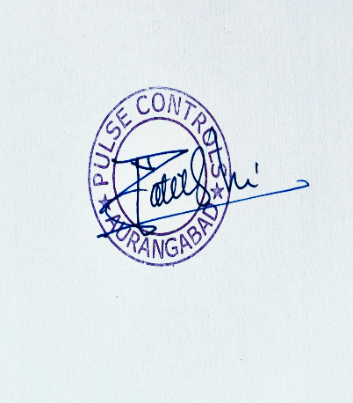

Thanks and regards

Nandkishor Patil

Sales and Service