To, Date:14-1-24

**ENDURANCE TECHNOLOGIES LIMITED**

**(SUSPENSION DIVISION)**

**K-228 & K-229, M.I.D.C. INDUSTRIAL AREA**

**POST BOX NO. 982, WALUJ**

**AURANGABAD - 431136 Maharashtra India**

Subject:  Material list and Condition

We M/S PULSE CONTROLS declare that we use all equipment and material as listed below with inspection date.

1.Testor -Taparia Condition good inspection date :01-01-24

2.Screw driver set -Taparia Condition good inspection date :01-1-24

3.Drill Machine: Bosch Condition good inspection date :01-1-24

4.Multimeter : Meco Condition good inspection date :01-1-24

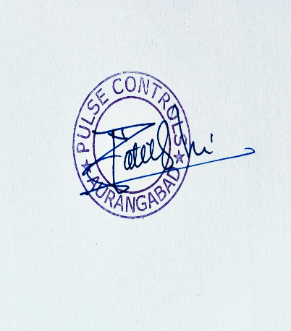

Thanks and regards

Nandkishor Patil

Sales and Service