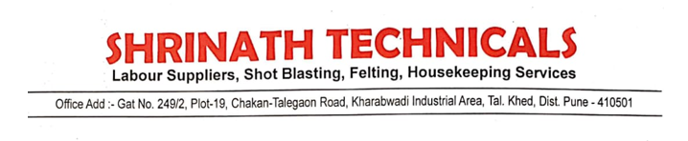

We M/S Shrinath Technicals decleared that our organization regularly inspect and maintain hand tools, machinery (cranes, vehicles, hoists/lifting tools, etc.) in case of any use.