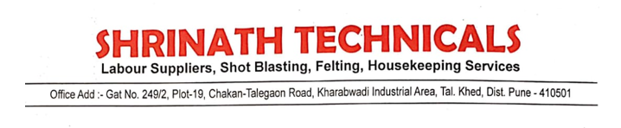

We M/S Shrinath Technicals decleared that  our all the tools and equipment comply with standards such as ISI Mark / Energy Efficient 5 star rating guidelines