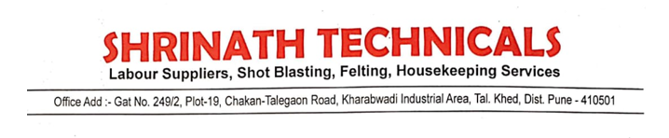

We M/S Shrinath Technicals decleared that  our all the tools and equipment holding handle of equipment in good condition