

Hindustan Water Treatment System

**TOTAL WATER MANAGEMENT**

**Supply PPE To Worker Record**

Date 10/01/2023

|  |  |  |  |  |  |  |  |  |  |
| --- | --- | --- | --- | --- | --- | --- | --- | --- | --- |
| Date |  | | | Place |  | | | | |
| Sr.No | Name | Dept. | Safety Shoes | Safety Goggle | Apron/Hand Gloves | Safety Belt | Safety Helmet | Dust Mask | Sign |
| 1 | Pradip Waghmare | Yes | Yes | Yes | Yes | Yes | Yes | Yes | Yes |
| 2 | Aakshy Joglekar | Yes | Yes | Yes | Yes | Yes | Yes | Yes | Yes |
| 3 | Umesh Pahilwan | Yes | Yes | Yes | Yes | Yes | Yes | Yes | Yes |
| 4 | Ajay Warma | Yes | Yes | Yes | Yes | Yes | Yes | Yes | Yes |

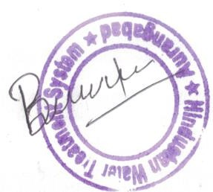

**Design office:- X-51 Bajaj Nagar ,Near Axis Bank ,Waluj Midc ,Aurangabad ,Maharashtra 431136 India.E-mail:- hindustanwater.sale@gmail.com/** [**hindustanwater.office@gmail.com**](mailto:hindustanwater.office@gmail.com) **,**

Cell - 09561922894 / 09975643257