ENDURANCE TECNOLOGIES PVT LTD

CONTRACTOR:-. HYDRO PNEUMATIC SERVICES (HPS)

Method statement

Introduction:- Air line installation
These procedures describe the method statement for installation Ducting & Support
Location: - Shop Floor

Job Detail: - Air line fabrication and erection

Tools and Equipment used –Resources:

Welding Mc, Grinding Mc, Drill Mc
Hammer, spanner
Platform Ladder
Hand pallet

PERSONAL.PPE’S
PPE will be used as per the activity
- General PPE- Safety Shoes, Safety Helmet, Reflective Jacket, Safety goggles, hand glove
- Height work- Full body safety harness + General PPE
- Hot work- Welding/Grinding faceshield, welding clothing, nose mask, leather hand gloves
- Covid 19 precautions- Covid face cover(If person closed to each other during work), surgical nose mask

Barricading of the work area:-
- Obtain proper work permit from Tetra pak before starting the work.
- Before the work is started, a brief safety talk shall be given on the scope of work and hazards Associated with the work to all the concerned for safety awareness
- Display of cautionary sign boards.
- Barricading of the work area is done by proper caution tape to avoid unauthorized persons entering the work area.

TRAINED WORKER INVOLVE IN THE ACTIVITY
- Working Area Identification
- Site survey before start activity by Experienced Engg/ Supervisor& EHS
- Trained worker for height work
- Trained and experience worker for hot work
- Continuous supervision by Engg/Supervisor

Inspection of Tools & Equipment to be used RO water line fabrication and erection work
:

- Inspection of the tools and equipment which shall be used in the activity
- Inspection checklist to be followed
- Inspection of mobile scaffold after erection and follow checklist
- Hand pallet should be checked & Ensure for damages
- Visual inspection of all power tools prior to start work, ELCB/RCCB is in operational condition

Following Hazards are identified and action is to be taken.

- All Equipment should be checked and inspected prior to use
- Man movement:-To be restricted by putting barricading and related safety observer to be deputed.
- Man movement is stop by putting barricading. Also informed to Tetra pak project team to coordinate with other contractor about lifting and necessary action. Full time safety observer to be deployed throughout lifting work.
- If communication system fails – Stop the job, inform to all team members, replan the task once
- All Machines and tools are tested and put tag “fit to use” for safe use
- Housekeeping should be done before start the work and after finish work to avoid personal injury
- TBT should be conducted and all safety regarding point shall be discussed. As per activity.
- Trained person shall be deployed
- Fire extinguisher and fire blanket shall be provided & combustible material shall be removed to prevent fire.
- PPEs shall be provided as per task. Full body safety harness must be used when working at height
- Continuous supervision shall be provided.

Safety Document /Specific Approval Required (Details of any safety documents or specific approval (i.e. Client specific approval) required to undertake the work)

- Work permit
- Fitness certificate of manpower
- ESI of all workers.
- WC Policy of workers / supervisors

Access & Egress to the work area: Give details of any special access or egress arrangements (i.e. Ladders/MEWPS/Scaffold/Trestles/Step Ladder etc.) that will be used including any obstruction/restriction in safe access to work area. Consider the site access from the public road onto and around the site before vehicles arrive on site, taking into account the site traffic management plan, the designated work area for delivery vehicles and the storage area for materials

- Access road for material shifting at work place to be surveyed before material movement. Any obstacles will be identified, and the route will be cleared.
- Ensuring to identify the Power Lines before starting work.
- Work area should be free from any obstacles.
- Ensuring the access for vehicle movement
- Temporary Caution tape should be marked before starting the work.
- Scaffold will be inspected prior to start height work and safety belt ll’be worn by workmen

Trained worker involved in the activity

- Supervisor to be available at site all time.
- Area to be cleaned on daily basis, all scrap material to be shifted to project scrap yard.
- All work shall be carried out under proper supervision.
- Use of PPE’S,
- Tool box talks before start of the work, JSA & Work permit for safe work.

Role & Responsibilities of Personnel/Parties Involved in activities:- Clearly define role and responsibilities of all personnel involved in activity i.e. Site management staff including subcontractors parties- Main contractor Project/Site Manager, Sub Contractor Site Manager, Project Engineer, OHS staff , Competent Supervisory Staff)

Endurance Site management Staff:
Site In-charge:

Hydro pneumatic services
Site Manager : Rakesh Kurhade
Permit Holder/Technicians: Engg/Supervisor – Jitendra Chavan
Site Manager-
- Overall responsibility for this project
- Check for any underground cables / OH Lines in the working area.
- Obtain Work clearance from location maintenance team before starting work,
- Check the condition & adequate capacity of Equipments/Machineries before starting of work.
- Issue work permit to contractor supervisor only after physical verification of work location.
- Ensuring 100% compliance to Risk assessment & Method statements.
- All workmen planned for this work shall be screened for medical fitness and deploy only if found medically fit checked by a qualified doctor.
- Check fitness of worker visually.
- Perform random supervision at site.
- Check the weather condition before start of work.

Supervisor/ Permit Holder/Contractor-
- Ensure the requirements of Work Permit
- Conduct Tool Box Talk in presence of Site Manager, Engineer and Safety Officer
- Work Permit received form Tetra Pak.
- Cross check the location before start the work
- Continuous supervision throughout the job
- Ensure good housekeeping of all sites
- Follow all instructions on occupational health and safety as dictated by Tetra Pak management from time to time
- Ensure that no unsafe act is performed at site
- Ensure safe & proper access and egress.
- Ensure that any unsafe condition observed at site is eradicated at the earliest
- Ensure pre-deployment inspection of all equipment, tools& tackles by Site Manager & HSE Engineer and use only if found to be “FIT TO USE”.

Safety Engineer- Kirankumar Khrlkar
- Check the weather condition before start of work.
- Conduct for Tool Box meeting with staff and workers before starting the activity.
- All workmen planned for this work shall be screened for medical fitness and deploy only if found medically fit by qualified doctor
- Check fitness of worker visually.
- Check for any underground / OH cables in the area and isolation if required.
- Ensure the Induction training for new workers.
- Close monitoring of activities and emergency preparedness.
- Barricading requirements to be decided and communicated to concerned.
- Check House Keeping.

Operative/Admin/Worker-
- Machine / operator documents verification.
- Participate in Toolbox Talks.
- Follow all instructions & safety guidelines given by the supervisors.
- Ensure the cleanliness and hygiene of workplace / access.
- Use correct Tools & Plant and report any damage or fault to supervisors for corrective measures.
- Use correct Personal Protective Equipment as directed and report any deficiencies to the Supervisor.
- Report all unsafe act & condition, incidents/near misses to the Supervisor.

Working/Activity Description: It is important that all operatives should have clear idea of those operational sequences and responsible supervisor must verify their competency prior to their engagement in operation.

Site survey, material unloading, measurement and marking, pipeline fabrication and welding, erection of scaffold, pipeline laying and connecting to existing water line, housekeeping the area(remove unwanted material), handover.

Details of Permits to Work required for activity: List out applicable Permits in sequence of work, for e.g. PTW(Permit to work), SFT, LAP(Limited access permit)

- General Work permit to be issued.
- Hot work permit
- Height work permit

Pre-Testing Checks

- Training / Induction
- Work Specific training
- Tool box talk
- Work permit
- Approved method statement and Approved risk assessment
- Availability of tools and Equipment as per requirement.
- Medical checkup of all workmen.

Resources (Equipment , tools including manpower)Details i.e. Equipment and Tools, specific operational equipment, test kits, lifting resources, Details of materials to be used in operation, Details of the manpower allocated to the task, e.g. titles, qualifications, competences, direct manpower, contractors. Details of plant, tools and equipment to be used for the work, including the availability of relevant statutory documents, checks or inspections etc.Details of fencing, barriers, cones, chains, dangers notices, warning signs etc.

6.6 Work Boundaries/ Schedule of authority clear description of the work boundaries, e.g. delineation details or terminal points etc. supported where appropriate with sketches or drawings. Access and egress should only be gained by designated access/egress points. Under no circumstances, any operational personnel will not be allowed to work beyond their defined schedule of authority as defined in Permit to work or their defined operational roles/responsibilities. Otherwise such breach should be considered as procedural violation.

All the workers shall be made familiar about emergency and safe assembly point in case of emergency.

Final Checks& restoration of work area after completion of work :- Those checks to be carried out by responsible supervisor in witness of his line hierarchy by use of specific checklist of certain operational checks and once those completed satisfactory, PTW(if applicable) to be closed and isolation arrangements to be restored by removing barricades/cautionary tags.
Evacuate all the site workers.
Removal of all balance materials.
Removal of tolls and plants.
Proper house keepings.
Close work permit after completion of work.

7.Emergency Provisions: -Relevant operational possibility of a programme in the case of emergency situation i.e. electrical supply restoration. In addition emergency response provisions i.e. first aiders, fire fighting, first aid arrangements, nearest onsite/offsite emergency response also to be considered during emergency planning.

In case of emergency:

- First Aid boxes, fire extinguishers are available.
- Site Supervisor has to report any incident immediately to Tetra Pak representative
- Site Engineer to alert First Aider immediately and he should reach at spot with first aid box and stretcher and provide first aid treatment.
- Raise the siren in case of emergency or serious incident.
- Safe assembly point communicated to all workers.
- Site Engineer to call ambulance depending on the nature of incident.
- Site Engineer Alerts to doctor and ask for treatment.
- Site Engineer to communicate to Project Manager immediately.

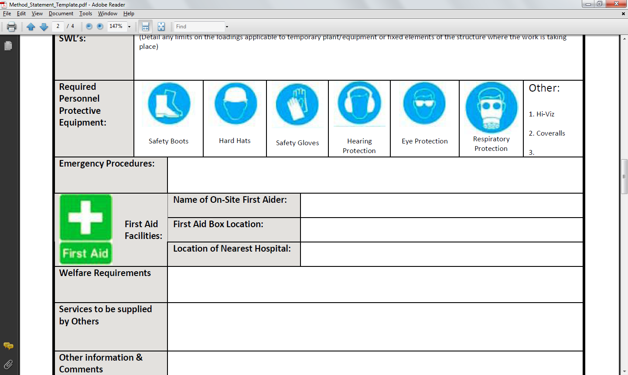

First Aid Room

8 Waste Disposal/Housekeeping and Environmental issues:-Details waste disposal processes and or housekeeping activities, Details of environmental impacts and control measures.

- After Completion of work, housekeeping to be carried out.
- Created debris will be stacked in specified location as instructed to the workers in TBM.

Personal Protective Equipment (PPE) :- PPE requirements for the task

- Safety Shoe
- Safety Helmets
- Reflective jackets
- Hand gloves
- Safety googles.
- Nose Mask
- Faceshield
- Full body safety harness

10.0 Appendices :- Attachments as mentioned in document.

- Approved Risk assesment

I undersigned have read, discussed and fully understand the above method statement and risk assessment on activity Ducting & Support fabrication and erection with existing line work and will adhere to all method of work and condition set down.

Name | Company | Designation | Date & Signature
Jitendra Chavan | HPS | Super wiser | 24/02/2023
Manu Kumar | HPS | Welder | 24/02/2023
Rakesh Kumar | HPS | Fitter | 24/02/2023
Chotelal | HPS | Helper | 2/03/2023
Dhurap | HPS | Helper | 2/03/2023



HYDRO PNEUMATIC SERVICES ENDURANCE TECHNOLOGIES

