**PROVIDENT FUND CODE NUMBER INTIMATION**

**EMPLOYEES' PROVIDENT FUND**

**www.epfindia.gov.in**

**(**

**A statutory Body under the Ministry of Labour and Employment,**



No : 10000392569AHD Date : 26/06/2020

**To**

UPDESH KUMAR

Proprietor

SHRI SHYAM ENTERPRISE

Room No 34 35 425 Bharwad Vas,

Bol Gam Sanand AHMEDABAD

GUJARAT - 382170

Sub: Allotment of Code Number to establishment M/s SHRI SHYAM ENTERPRISE under Employees' Provident Fund and Miscellaneous Provisions Act, 1952-regarding.

**Sir/Madam ,**

|  |
| --- |
| - Any license/certificate/number issued by any Govt. |

Based on the information submitted online by you, your establishment is registered with Employees' Provident Fund Organisation with the following code number :

**Code Number : GJAHD2120685000**

This code number is allotted based on the following declarations by you:

|  |  |
| --- | --- |
| 1. Name of Establishment 2. PAN of Establishment 3. Date on which employment strength crossed 19 4. Section under which 5. Primary Activity 6. Ownership Type | : SHRI SHYAM ENTERPRISE  : CKMPK9630G  : 15/06/2020  : 0000001(4)  : EXPERT SERVICES  : Proprietorship Firm |

1. The address proof of the : establishment is

|  |  |
| --- | --- |
| *Application Number : 10000392569* | Page 1 of 2 |

*Code Number : GJAHD2120685000*

1. The proof of date of set up 05/06/2020 is Commencement of business by the Registrar of Companies
2. As at the time of application, your establishment is having the following licenses and registrations :

|  |  |  |  |  |  |
| --- | --- | --- | --- | --- | --- |
| **S.No.** | **License Under** | **License Number** | **Date** | **Issued By** | **Place of Issue** |
| 41706  4 | GOODS AND SERVICE  TAX IDENTIFICATION  NUMBER | 24CKMPK9630G1ZY | 05/06/2020 | Government Of India | India |

1. As on date of your application, your establishment is not registered with ESIC.
2. As on date of your application, your establishment is not having LIN.

**REGIONAL OFFICE**

**AHMEDABAD**

**Room No 34 35 425 Bharwad Vas, 382170 updesh6362@gmail.com**

Please note that this intimation letter is generated with the Owners' Details in Form 5A and the intimated letter will be valid only if the Form 5A is enclosed.

**Important information:**

1. By virtue of this registration, you are required to comply with the provision of the EPF & MP Act 1952. The obligations/duties/responsibilities cast upon you as an employer of this establishment and penalties, on account of noncompliance with the same, are explained on our website **www.epfindia.gov.in**. You are required to go through them carefully.
2. Remittance of dues under the provisions of the Act is to be made only through a Challan generated through the Unified portal. (The process for registration on the portal, preparation of the ECR txt file and related information is available on the website and the portal).
3. **In case this letter is produced as a proof of the code number of the establishment, before any person including any Inspector from EPFO, the Form 5A generated through the portal at the time of registration should be a part of this letter. The remittance details of the establishment will be available on the EPFO website through the link "Establishment Search" where all payments from December 2016 onwards with the names of employees are available.**
4. Please quote the Code Number GJAHD2120685000 for all the future correspondence with EPFO.

This is a system generated letter and needs no signature.

Employees' Provident Fund Organisation

**Dated: 26/06/2020**

*Application Number : 10000392569* Page 2 of 2

*Code Number : GJAHD2120685000*

**EMPLOYEE'S PROVIDENT FUND**

**ELECTRONIC CHALLAN CUM RETURN (ECR)**

|  |  |  |  |
| --- | --- | --- | --- |
| Name of Establishment | SHRI SHYAM ENTERPRISE | | |
| Establishment Id | GJAHD2120685000 | LIN | 1690735084 |
| Wage Month | FEB-2023 | Return Month | MAR-2023 |
| Contribution Rate (%) | 12 | ECR Type | ECR |
| Salary Disbursement Date | 20-MAR-2023 | Uploaded Date Time | 20- MAR -2023 11:08 |
| Exemption Status | Unexempted | TRRN Number |  |
| Remarks | EPF CHALLAN FEB-2023 | ECR Id | 86631071 |
| Total Members | 95 |  |  |
| **Contribution and Remittance Details (I n Rupees) :** | | | |
| Total EPF Contribution Remitted | 36,595 | Total EPS Contribution Remitted | 25,392 |
| Total EPF-EPS Contribution Remitted | 11,203 | Total Refund Advance | 0 |
| **PMRPY Upfront Benefit Details (In Rup ees) :** | | | |
| Total PMRPY Upfront EPF Amount | 0 | Total PMRPY Upfront EPS Amount | 0 |
| PMRPY benefit remarks | NA | | |
| **ABRY Upfront Benefit Details (In Rupe es) :** | | | |
| Total ABRY benefit Amount | Employee EPF Share | Employer EPS Share | Employer EPF Share |
| 0 | 0 | 0 |
| ABRY benefit remarks | Establishment is not eligible for ABRY benefit as eligible employee count [2] is less than required employee count of five from base month. | | |

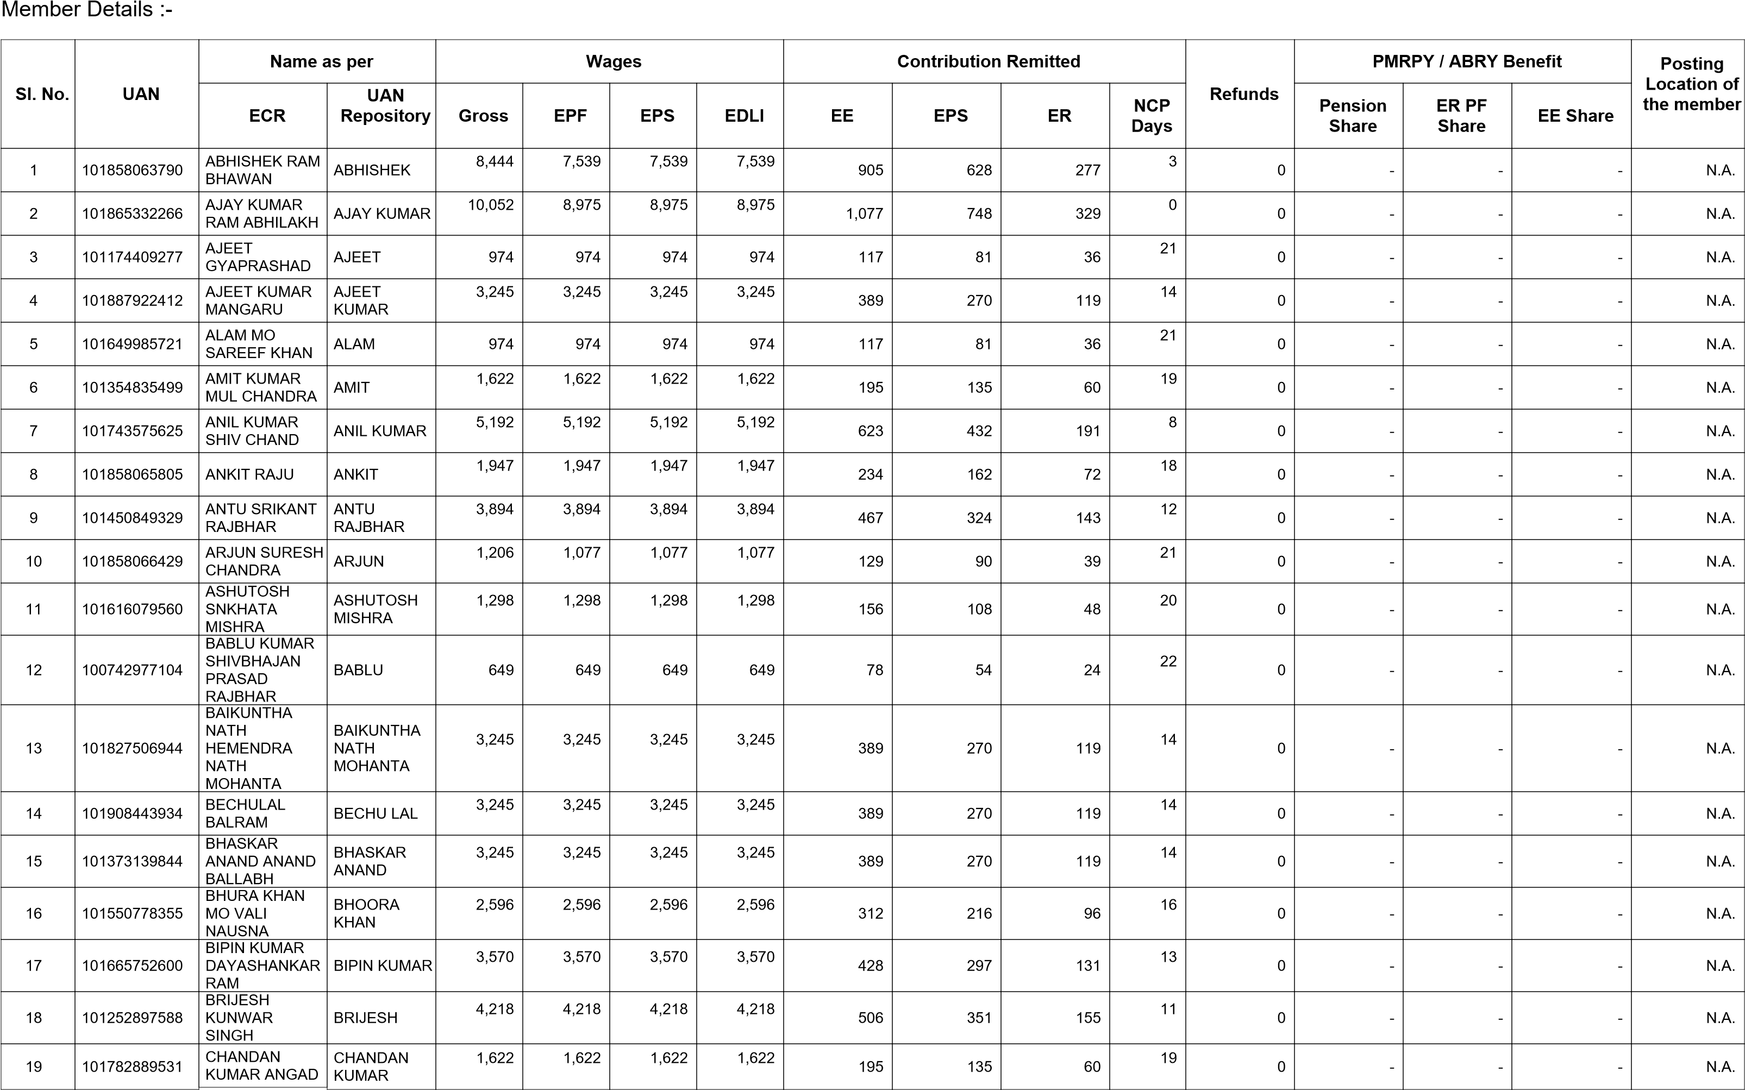

|  |  |  |  |  |  |  |  |  |  |  |  |  |  |  |  |  |
| --- | --- | --- | --- | --- | --- | --- | --- | --- | --- | --- | --- | --- | --- | --- | --- | --- |
| **Sl. No.** | **UAN** | **Name as per** | |  | **Wages** | |  |  | **Contribution Remitted** | | | **Refunds** | **PMRPY / ABRY Benefit** | | | **Posting**  **Location of the member** |
| **ECR** | **UAN**  **Repository** | **Gross** | **EPF** | **EPS** | **EDLI** | **EE** | **EPS** | **ER** | **NCP**  **Days** | **Pension Share** | **ER PF Share** | **EE Share** |
|  |  | BIND |  | |  | |  |  |  | | | | | | | |
| 20 | 100798772179 | DAHARI BAL  CHANDER | DAHARI | 3,245 | 3,245 | 3,245 | 3,245 | 389 | 270 | 119 | 14 | 0 | - | - | - | N.A. |
| 21 | 101450236839 | DEELIP KUMAR  MOTI LAL  CHAUHAN | DEELIP  KUMAR | 3,894 | 3,894 | 3,894 | 3,894 | 467 | 324 | 143 | 12 | 0 | - | - | - | N.A. |
| 22 | 101694299827 | DEEPAK RAM MUSAFIR | DEEPAK KUMAR | 5,192 | 5,192 | 5,192 | 5,192 | 623 | 432 | 191 | 8 | 0 | - | - | - | N.A. |
| 23 | 101887562661 | DHANESHWAR  CHHOTAK  PRASAD | DHANESHWA R | 3,245 | 3,245 | 3,245 | 3,245 | 389 | 270 | 119 | 14 | 0 | - | - | - | N.A. |
| 24 | 101645222027 | DHARMENDRA  KUMAR ASHOK  RAJBHAR | DHARMENDR A KUMAR | 3,245 | 3,245 | 3,245 | 3,245 | 389 | 270 | 119 | 14 | 0 | - | - | - | N.A. |
| 25 | 101403616900 | DHARMENDRA  KUMAR  GANESH  PRASAD | DHARMENDR A KUMAR | 9,248 | 8,257 | 8,257 | 8,257 | 991 | 688 | 303 | 1 | 0 | - | - | - | N.A. |
| 26 | 101809209205 | DILIP KUMAR JHABBAR | DILIP KUMAR | 9,248 | 8,257 | 8,257 | 8,257 | 991 | 688 | 303 | 1 | 0 | - | - | - | N.A. |
| 27 | 101560599108 | DEEPAK BIND  RAMASHANKAR | DIPAK BIND | 3,245 | 3,245 | 3,245 | 3,245 | 389 | 270 | 119 | 14 | 0 | - | - | - | N.A. |
| 28 | 101703384883 | DURGESH SUKHDEV | DURGESH | 1,206 | 1,077 | 1,077 | 1,077 | 129 | 90 | 39 | 21 | 0 | - | - | - | N.A. |
| 29 | 101910183700 | FESHAL WAJID  ALI | FESHAL | 3,245 | 3,245 | 3,245 | 3,245 | 389 | 270 | 119 | 14 | 0 | - | - | - | N.A. |
| 30 | 101294259056 | FUL SINGH  GANGA RAM | FUL SINGH | 649 | 649 | 649 | 649 | 78 | 54 | 24 | 22 | 0 | - | - | - | N.A. |
| 31 | 101377457868 | GAURAV  KUSHWAHA OM  PRAKASH | GAURAV  KUSHWAHA | 1,947 | 1,947 | 1,947 | 1,947 | 234 | 162 | 72 | 18 | 0 | - | - | - | N.A. |
| 32 | 101340838581 | GAURISHANKER HARISHCHAND | GAURISHANK ER | 2,920 | 2,920 | 2,920 | 2,920 | 350 | 243 | 107 | 15 | 0 | - | - | - | N.A. |
| 33 | 100995148815 | GOVIND  RAMSEVAK | GOVIND | 1,298 | 1,298 | 1,298 | 1,298 | 156 | 108 | 48 | 20 | 0 | - | - | - | N.A. |
| 34 | 100858264765 | GUDDU AMIR CHANDRA | GUDDU | 5,192 | 5,192 | 5,192 | 5,192 | 623 | 432 | 191 | 8 | 0 | - | - | - | N.A. |
| 35 | 100891047454 | HIMANSHU  SINGH OMKAR  KUSHWAHA | HIMANSHU  SINGH  KUSHWAHA | 6,835 | 6,103 | 6,103 | 6,103 | 732 | 508 | 224 | 7 | 0 | - | - | - | N.A. |
| 36 | 101358365664 | ISRAR KHAN  ISHTYAK KHAN | ISRAR KHAN | 3,245 | 3,245 | 3,245 | 3,245 | 389 | 270 | 119 | 14 | 0 | - | - | - | N.A. |
| 37 | 101783856473 | JAIN RAM  RAJINDER  KUMAR | JAIN RAM | 3,245 | 3,245 | 3,245 | 3,245 | 389 | 270 | 119 | 14 | 0 | - | - | - | N.A. |
| 38 | 101887561184 | JITENDRA  KUMAR BIND  VISHWANATH | JITENDRA  KUMAR BIND | 3,245 | 3,245 | 3,245 | 3,245 | 389 | 270 | 119 | 14 | 0 | - | - | - | N.A. |

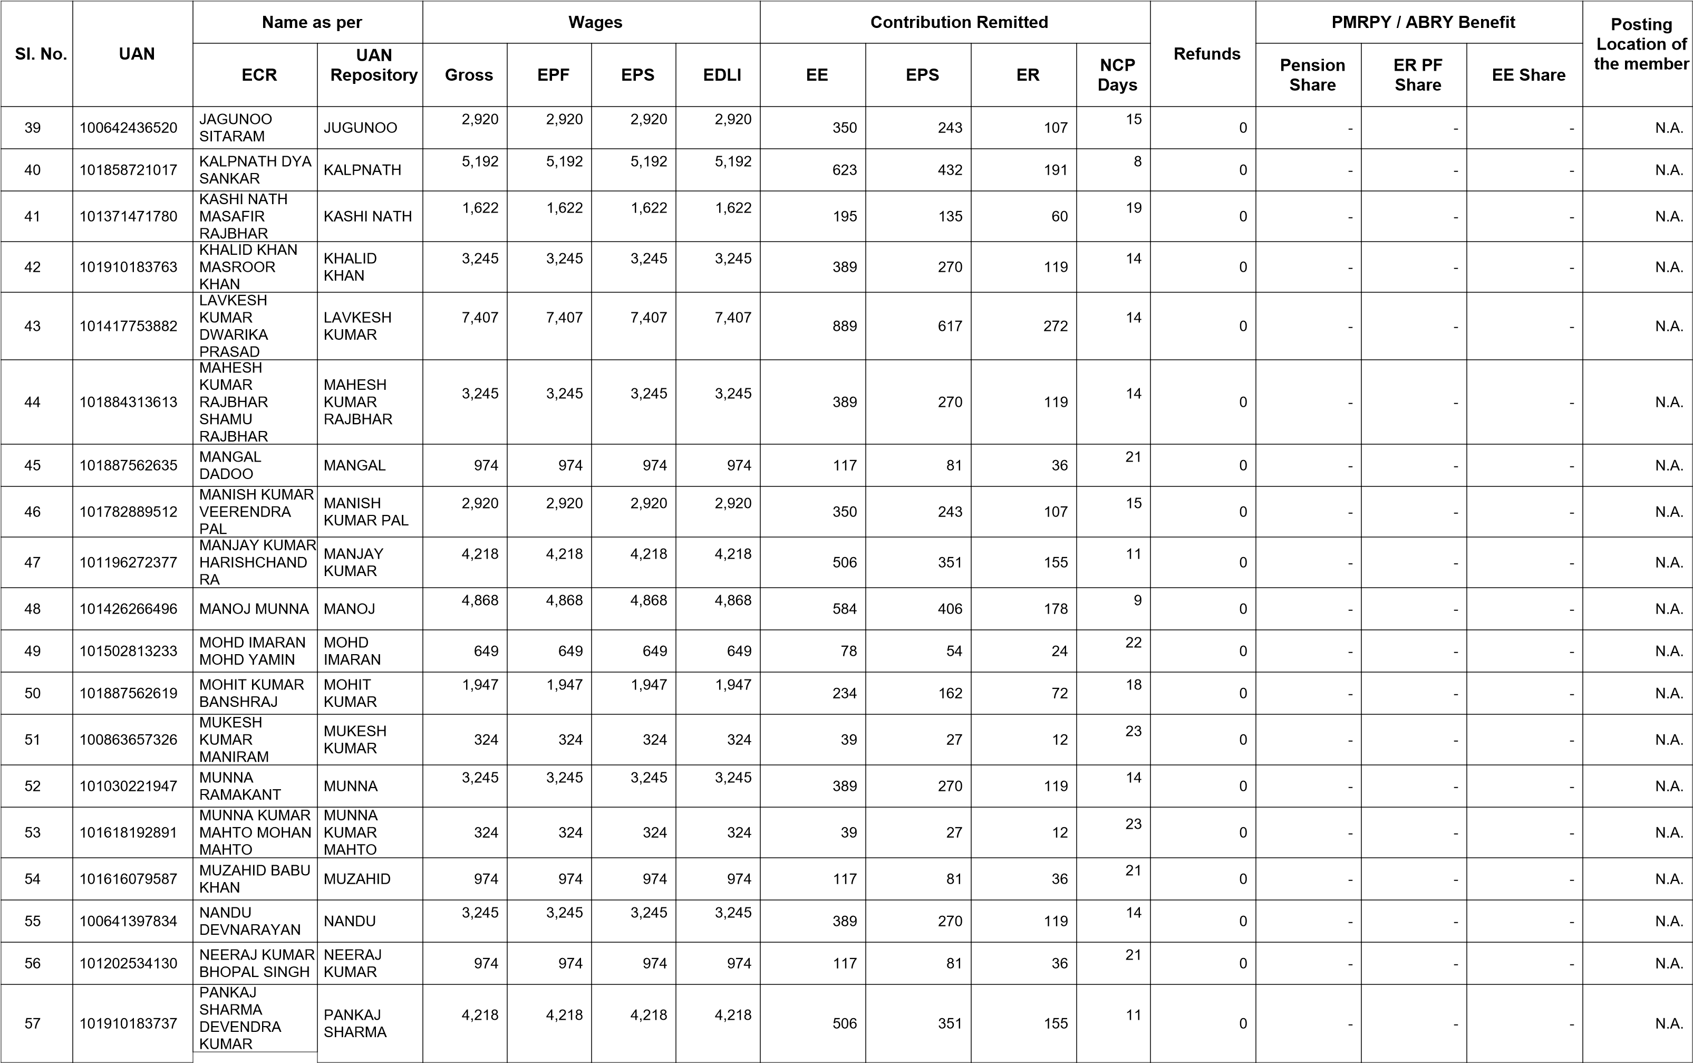

|  |  |  |  |  |  |  |  |  |  |  |  |  |  |  |  |  |
| --- | --- | --- | --- | --- | --- | --- | --- | --- | --- | --- | --- | --- | --- | --- | --- | --- |
| **Sl. No.** | **UAN** | **Name as per** | |  | **Wages** | |  |  | **Contribution Remitted** | | | **Refunds** | **PMRPY / ABRY Benefit** | | | **Posting**  **Location of the member** |
| **ECR** | **UAN**  **Repository** | **Gross** | **EPF** | **EPS** | **EDLI** | **EE** | **EPS** | **ER** | **NCP**  **Days** | **Pension Share** | **ER PF Share** | **EE Share** |
|  |  | SHARMA |  | |  | |  |  |  | | | | | | | |
| 58 | 101887562626 | PARBIN KUMAR RAJARAM | PARBIN KUMAR | 3,894 | 3,894 | 3,894 | 3,894 | 467 | 324 | 143 | 12 | 0 | - | - | - | N.A. |
| 59 | 101340838523 | PRADEEP TINKOO | PRADEEP | 8,042 | 7,180 | 7,180 | 7,180 | 862 | 598 | 264 | 4 | 0 | - | - | - | N.A. |
| 60 | 101865332250 | PRAMENDR  KUMAR RAMU | PRAMENDR KUMAR | 8,846 | 7,898 | 7,898 | 7,898 | 948 | 658 | 290 | 2 | 0 | - | - | - | N.A. |
| 61 | 101633651287 | PRAMOD  KUMAR  HARDEV | PRAMOD KUMAR | 3,245 | 3,245 | 3,245 | 3,245 | 389 | 270 | 119 | 14 | 0 | - | - | - | N.A. |
| 62 | 101252897638 | PRAMOD  KUMAR SINGH  KUWAR SHING | PRAMOD  KUMAR  SINGH | 3,894 | 3,894 | 3,894 | 3,894 | 467 | 324 | 143 | 12 | 0 | - | - | - | N.A. |
| 63 | 101564234218 | PARVESH  KUMAR DHARM  RAJ | PRAVESH KUMAR | 3,245 | 3,245 | 3,245 | 3,245 | 389 | 270 | 119 | 14 | 0 | - | - | - | N.A. |
| 64 | 101457016396 | RAJAN KUMAR BRANHADIN | RAJAN  KUMAR | 1,622 | 1,622 | 1,622 | 1,622 | 195 | 135 | 60 | 19 | 0 | - | - | - | N.A. |
| 65 | 100674435730 | RAJENDRA RAM AKUL RAM | RAJENDRA RAM | 649 | 649 | 649 | 649 | 78 | 54 | 24 | 22 | 0 | - | - | - | N.A. |
| 66 | 101642831543 | RAJESH  GAUTAM  KAMALESH  RAM | RAJESH  GAUTAM | 3,245 | 3,245 | 3,245 | 3,245 | 389 | 270 | 119 | 14 | 0 | - | - | - | N.A. |
| 67 | 101718688914 | RAJESH KUMAR GURUDEEN | RAJESH KUMAR | 8,042 | 7,180 | 7,180 | 7,180 | 862 | 598 | 264 | 4 | 0 | - | - | - | N.A. |
| 68 | 101300273813 | RAJU KUMAR PRAHLAD | RAJU KUMAR | 3,245 | 3,245 | 3,245 | 3,245 | 389 | 270 | 119 | 14 | 0 | - | - | - | N.A. |
| 69 | 101154618046 | RAJU KUMAR BECHU | RAJU KUMAR | 3,894 | 3,894 | 3,894 | 3,894 | 467 | 324 | 143 | 12 | 0 | - | - | - | N.A. |
| 70 | 101887562657 | RASHID KHAN  SARAVAR KHAN | RASHID KHAN | 3,245 | 3,245 | 3,245 | 3,245 | 389 | 270 | 119 | 14 | 0 | - | - | - | N.A. |
| 71 | 101196272365 | RISHI BECHU RAJBHAR | RISHI | 2,920 | 2,920 | 2,920 | 2,920 | 350 | 243 | 107 | 15 | 0 | - | - | - | N.A. |
| 72 | 101165636310 | RUDAL KUMAR  RUPCHAND  RAJBHAR | RUDAL  KUMAR | 3,245 | 3,245 | 3,245 | 3,245 | 389 | 270 | 119 | 14 | 0 | - | - | - | N.A. |
| 73 | 101884655363 | SAHAJRAM MALHE | SAHAJRAM | 1,608 | 1,436 | 1,436 | 1,436 | 172 | 120 | 52 | 20 | 0 | - | - | - | N.A. |
| 74 | 101495575973 | SANDEEP  PATEL  SURYABHAN  SINGH | SANDEEP PATEL | 324 | 324 | 324 | 324 | 39 | 27 | 12 | 23 | 0 | - | - | - | N.A. |
| 75 | 101369089864 | SANJAY KUMAR HARISHCHAND | SANJAY KUMAR | 3,570 | 3,570 | 3,570 | 3,570 | 428 | 297 | 131 | 13 | 0 | - | - | - | N.A. |
| 76 | 101910183697 | SARMAN  KUMAR  CHHUNNA  SINGH | SARMAN KUMAR | 3,245 | 3,245 | 3,245 | 3,245 | 389 | 270 | 119 | 14 | 0 | - | - | - | N.A. |
| **Sl. No.** | **UAN** | **Name as per** | |  | **Wages** | |  |  | **Contribution Remitted** | | | **Refunds** | **PMRPY / ABRY Benefit** | | | **Posting**  **Location of the member** |
| **ECR** | **UAN**  **Repository** | **Gross** | **EPF** | **EPS** | **EDLI** | **EE** | **EPS** | **ER** | **NCP**  **Days** | **Pension Share** | **ER PF Share** | **EE Share** |
| 77 | 101830281242 | SARVESH  KUMAR RAJESH  KUMAR | SARVESH KUMAR | 3,245 | 3,245 | 3,245 | 3,245 | 389 | 270 | 119 | 14 | 0 | - | - | - | N.A. |
| 78 | 101517909506 | SAURABH  SHARMA  GHANSHAYAM  SHARMA | SAURABH SHARMA | 3,245 | 3,245 | 3,245 | 3,245 | 389 | 270 | 119 | 14 | 0 | - | - | - | N.A. |
| 79 | 101718688876 | SHANI KUMAR NANDLAL | SHANI  KUMAR | 3,570 | 3,570 | 3,570 | 3,570 | 428 | 297 | 131 | 13 | 0 | - | - | - | N.A. |
| 80 | 101910183716 | SHIVAM RAJAN SINGH | SHIVAM | 3,894 | 3,894 | 3,894 | 3,894 | 467 | 324 | 143 | 12 | 0 | - | - | - | N.A. |
| 81 | 101910183684 | SHOEV KHAN ARIF KHAN | SHOEV KHAN | 3,245 | 3,245 | 3,245 | 3,245 | 389 | 270 | 119 | 14 | 0 | - | - | - | N.A. |
| 82 | 101660294899 | SHUBHAM  RAAM GOPAAL  MISHRA | SHUBHAM MISHRA | 1,298 | 1,298 | 1,298 | 1,298 | 156 | 108 | 48 | 20 | 0 | - | - | - | N.A. |
| 83 | 101910183759 | SHYAM JI  RAJENDRA  KUMAR | SHYAM JI | 3,570 | 3,570 | 3,570 | 3,570 | 428 | 297 | 131 | 13 | 0 | - | - | - | N.A. |
| 84 | 101018937005 | SOBINDRA  KUMAR RAM  SEWAK | SOBINDRA KUMAR | 1,622 | 1,622 | 1,622 | 1,622 | 195 | 135 | 60 | 19 | 0 | - | - | - | N.A. |
| 85 | 101887562642 | SONU  RAMJIMAL | SONU | 3,245 | 3,245 | 3,245 | 3,245 | 389 | 270 | 119 | 14 | 0 | - | - | - | N.A. |
| 86 | 101437179785 | SUNEEL KUMAR UMA SHANKAR | SUNEEL KUMAR | 1,622 | 1,622 | 1,622 | 1,622 | 195 | 135 | 60 | 19 | 0 | - | - | - | N.A. |
| 87 | 101616079600 | SUNIL KUMAR  KOMAL PRASAD | SUNIL  KUMAR | 5,192 | 5,192 | 5,192 | 5,192 | 623 | 432 | 191 | 8 | 0 | - | - | - | N.A. |
| 88 | 101369089855 | SURAJ RAM  VISHAL  VISHWKARMA | SURAJ | 3,894 | 3,894 | 3,894 | 3,894 | 467 | 324 | 143 | 12 | 0 | - | - | - | N.A. |
| 89 | 101832542967 | UVESH KHAN IDRISH | UVESH KHAN | 324 | 324 | 324 | 324 | 39 | 27 | 12 | 23 | 0 | - | - | - | N.A. |
| 90 | 101593895752 | VIJAY  SURYBHAN  RAJBHAR | VIJAY | 3,570 | 3,570 | 3,570 | 3,570 | 428 | 297 | 131 | 13 | 0 | - | - | - | N.A. |
| 91 | 101827506959 | VIJAY SINGH  GANGARAM | VIJAY SINGH | 649 | 649 | 649 | 649 | 78 | 54 | 24 | 22 | 0 | - | - | - | N.A. |
| 92 | 101371471767 | VIJAYSHANKAR RAMASHRAY | VIJAYSHANK AR | 1,298 | 1,298 | 1,298 | 1,298 | 156 | 108 | 48 | 20 | 0 | - | - | - | N.A. |
| 93 | 101625818583 | VINDHYACHAL  RAM CHHEDI  RAM | VINDHYACHA L RAM | 3,894 | 3,894 | 3,894 | 3,894 | 467 | 324 | 143 | 12 | 0 | - | - | - | N.A. |
| 94 | 101168018233 | VIRENDRA  DHARMOO | VIRENDRA | 4,868 | 4,868 | 4,868 | 4,868 | 584 | 406 | 178 | 9 | 0 | - | - | - | N.A. |
| 95 | 101089822032 | VIRENDRA  PRATAP  CHANDRAPAL | VIRENDRA PRATAP | 3,245 | 3,245 | 3,245 | 3,245 | 389 | 270 | 119 | 14 | 0 | - | - | - | N.A. |

***Note:***

1. ***UANs are prefixed with Asterisk sign (*) in case AADHAAR is not seeded /unverified***
2. ***EPS Contribution Remitted is prefixed with Hash sign (#) when Member's age is more than 58 years. Please ensure that this is the case of "Deferred Pension".***

PMRPY Benefit Not Given Remarks :- ABRY Benefit Not Given Remarks :-

|  |  |  |  |  |
| --- | --- | --- | --- | --- |
| **Reason Code** | **Reason Name** |  | **Reason Code** | **Reason Name** |
| EC10001 | ECR already filed for this member | GK10001 | EPF wages are greatter than or equal to 15,000/- |
| EC10002 | Parallel Employment: ECR already filed for this | GK10002 | Mismatch in EPF and EPS wages |
| EC10003 | Benefit already availed for this member | GK10003 | EPF contribution remitted is greatter than due remittance |
| EC10004 | Gross/EPF wages greater than 15,000/- | GK10004 | EPS contribution remitted is greatter than due remittance |
| EC10005 | Mismatch in EPF and EPS wages | GK10005 | ( EPF - EPS) diffrence contribution remitted is greatter than due |
| EC10006 | Mismatch in Due and Remitted values | GK10006 | EPS contribution remitted is greatter than due remittance |
| EC10007 | UAN Deactivated | GK10007 | Aadhaar not seeded |