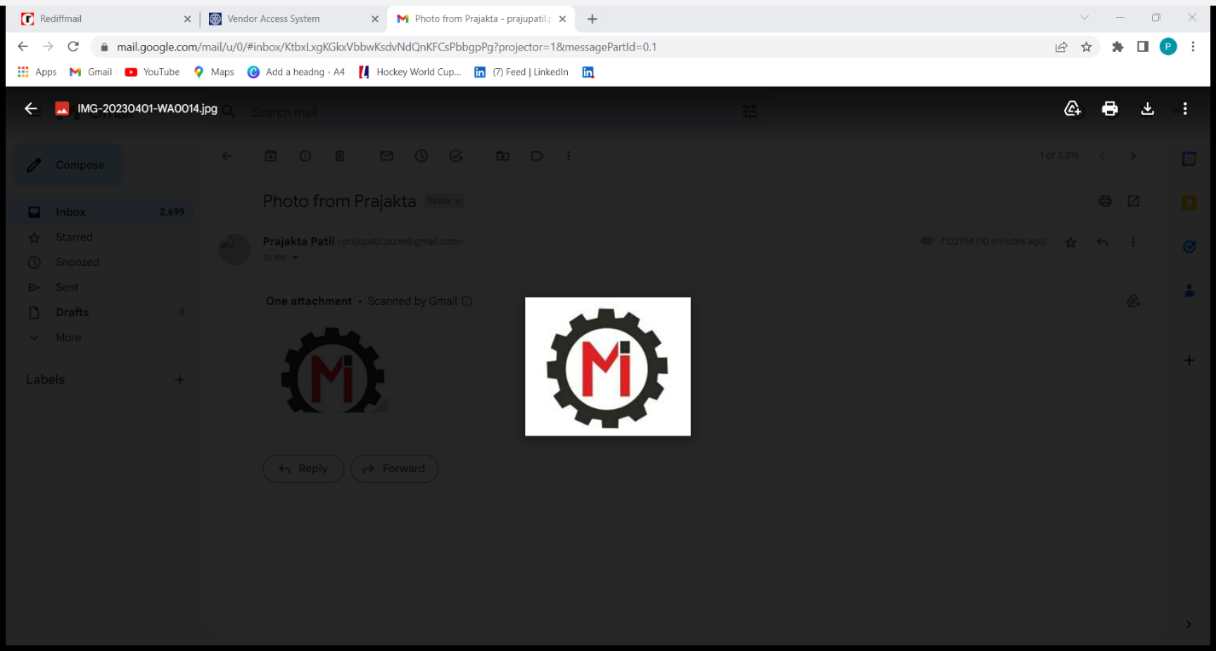Mahalaxmi Industries
Fabrication Work & Labour Supplier
Rajan Hsg. Soc , RH-129,Flat No-4,Shahunagar ,Chinchwad , Pune-411019
Tel:Email :mahalaxmiindustriespune@rediffmail.com
GSTIN:27AAOFM6468N1ZB, State:Maharashtra.Code:27

ORGANIZATIONAL CHART
PARTNERS

Pratiksha Patil Darshana Polkam

Supervisor Welder

