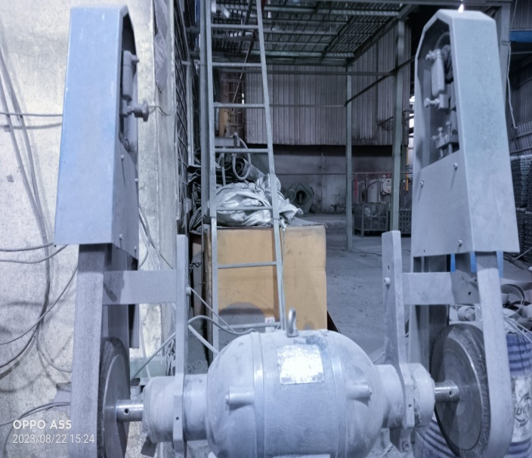

**Dust machine cover available**.

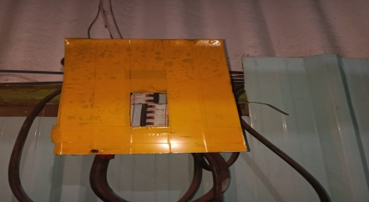

**Electrical panel cover provide.**

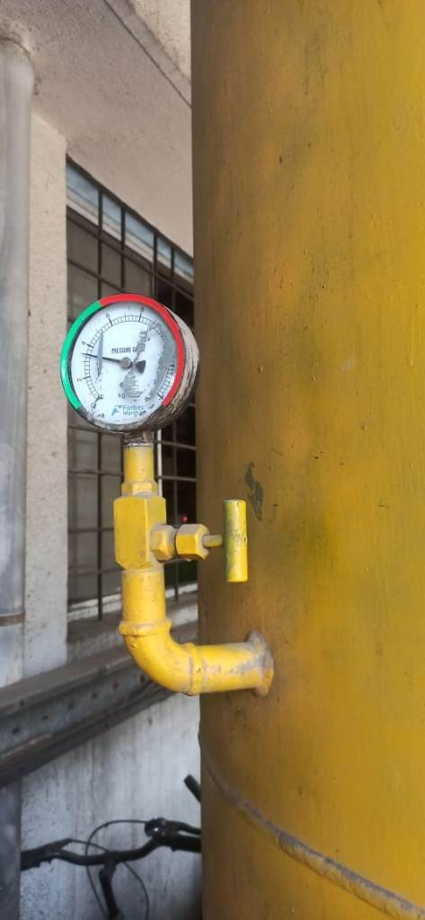

**Safe working pressure is mark on pressure gauge of N2 plant.**