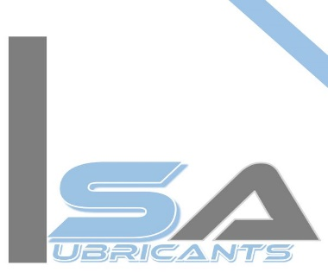

To, Date :29/03/2022

[sa.lubricants01@gmail.com](mailto:sa.lubricants01@gmail.com) 

+919595959846,9823922777 

Gut No.54, plot no.455,56 &483,84 

Aadarsh Nagar Shajapur MIDC Waluj

Aurangabad.

Endurance Technologies LTD.

MIDC Waluj Aurangabad.

Sub :- Declaration for Fire

Respected sir,

I Am Shaikh Abdul Hafeez Owner of S.A. Lubricants declare that from the time we are working , there has not been any fire incident because our job is only load the vehicles.