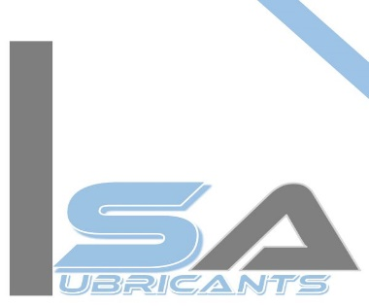

Endurance Technologies LTD.

MIDC Waluj Aurangabad.

**Sub:- Declaration for Accidents**

Respected sir,

I Am shaikh Abdul Hafeez Owner of S.A.lubricants declare that from the time we are working , there has not been any accident till date. Because we give all the safety stuff, If an accident happens, we have labor insurance, no.2307002722P102158478 valid till 08/06/2023.

To, Date :18/08/22

Gut No.54, plot no.455/484

Shajapur MIDC Waluj

Aurangabad.

 [sa.lubricants01@gmail.com](mailto:sa.lubricants01@gmail.com)

 +919595959846,9823922777