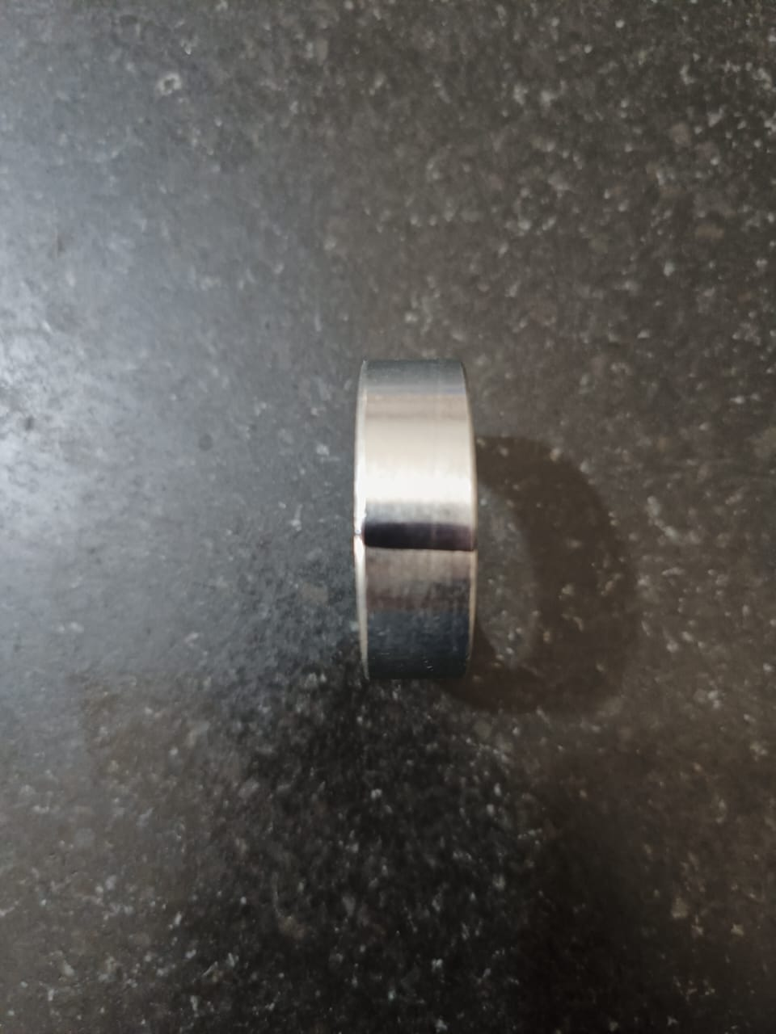 **After 100% Visual Inspection OD Marks With Black Marker.**