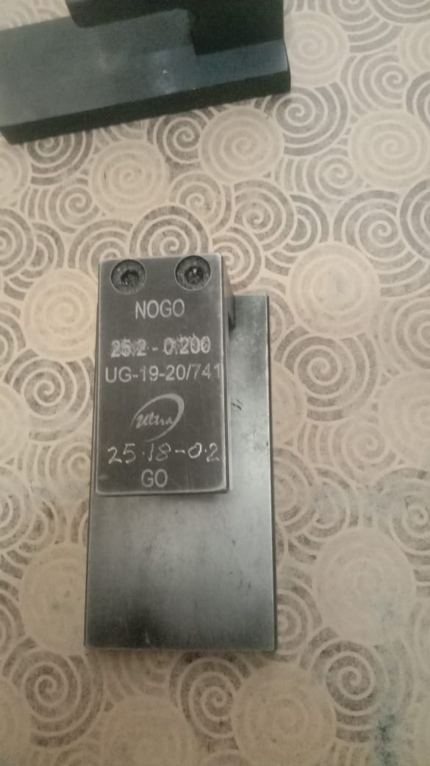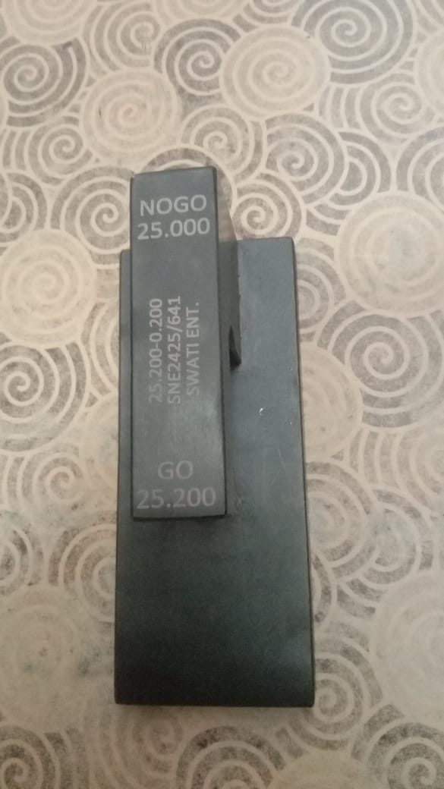

Length Gauge On Parting Machine (spec-25.00/25.18mm)

Length Gauge On Final Inspection stage (as Per Drg spec-25.00/25.20)