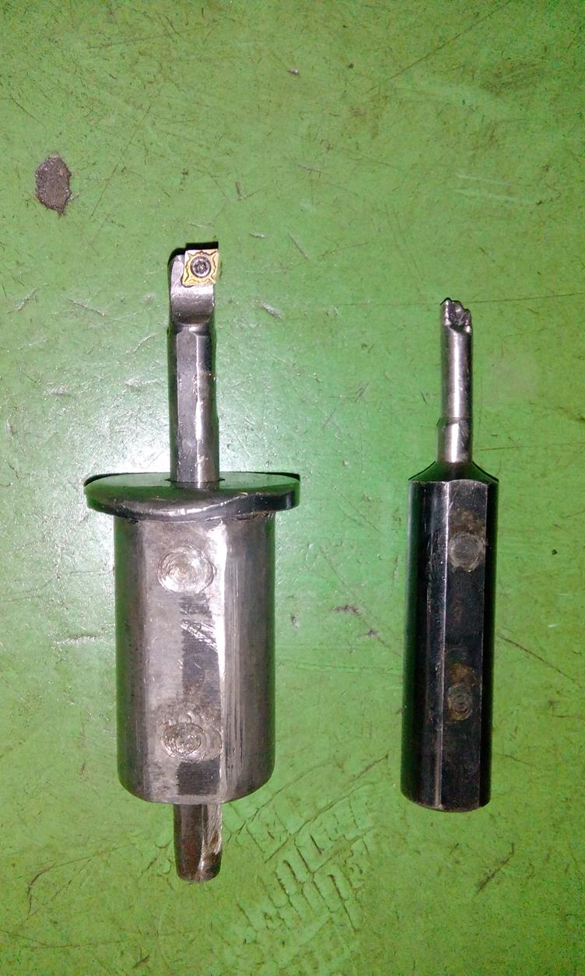

Boring Tool Shank dia 11.00mm

