[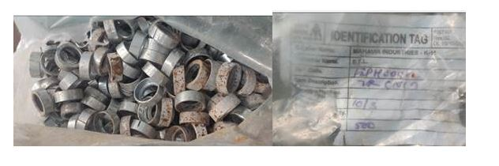](https://vcportal.endurancegroup.com/data/qfrdoc/hu2g3xnwwdoxzi2mq5cqmlnm.jpg)

The bag was torn during handling of finished goods without a trolley.