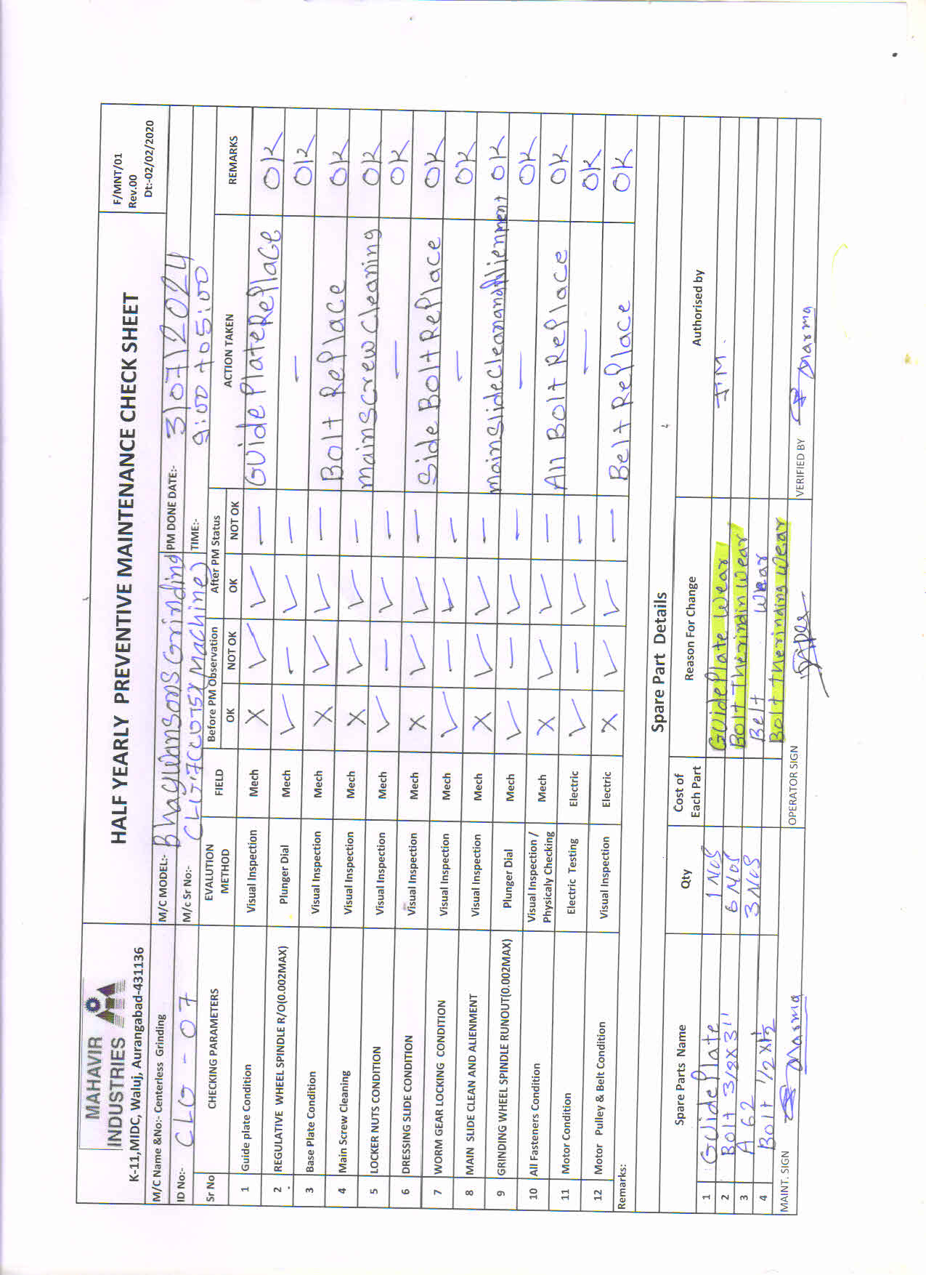

**As per Schedule PM Done of CLG-07 and As per PM Check Sheet All Locking Screw Replace of Control Wheel slide.**