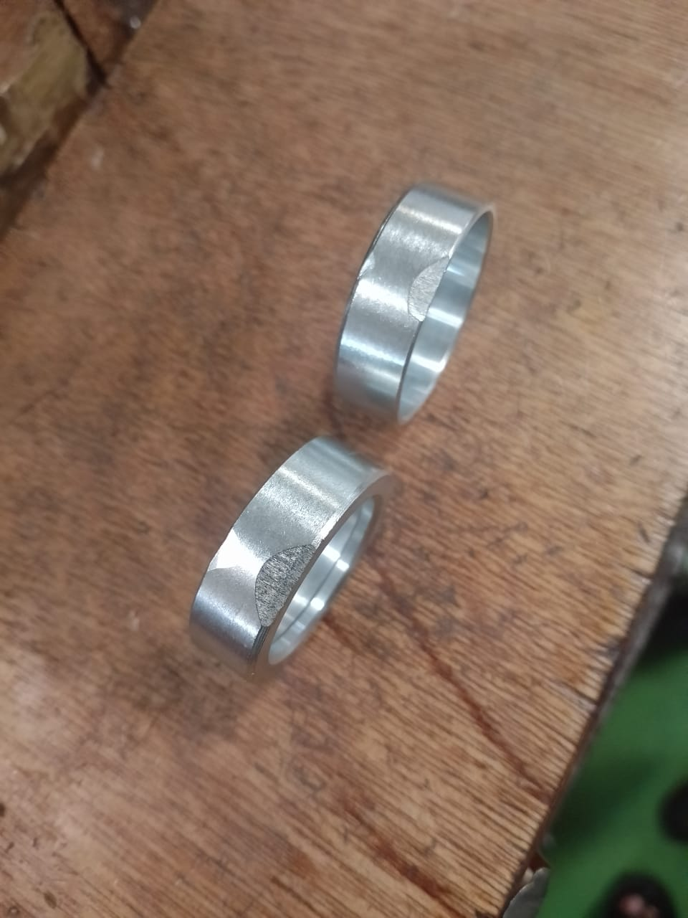

OD Damage Obs-OD cut marks